BÁO CÁO THỰC HÀNH LAB 2 LẬP TRÌNH HƯỚNG ĐỐI TƯỢNG
Table of Contents
Table of Figures 1
- Use Case Diagram 3
- Class Diagram 4
- Source Code 5
  - Aims Class 5
  - DigitalVideoDisc Class 6
  - Cart Class 8
- Kết quả demo 10
Table of Figures
Figure 1: Use Case Diagram 3
Figure 2: Class Diagram 4
Figure 3: Aims Class 5
Figure 4: DigitalVideoDisc Class 1 6
Figure 5: DigitalVideoDisc Class 2 7
Figure 6: Cart Class 1 8
Figure 7: Cart Class 2 9
Figure 8: Code Demo 10
Figure 9: Result 11
Figure 10: Getter and Setter Methods 12

Use Case Diagram

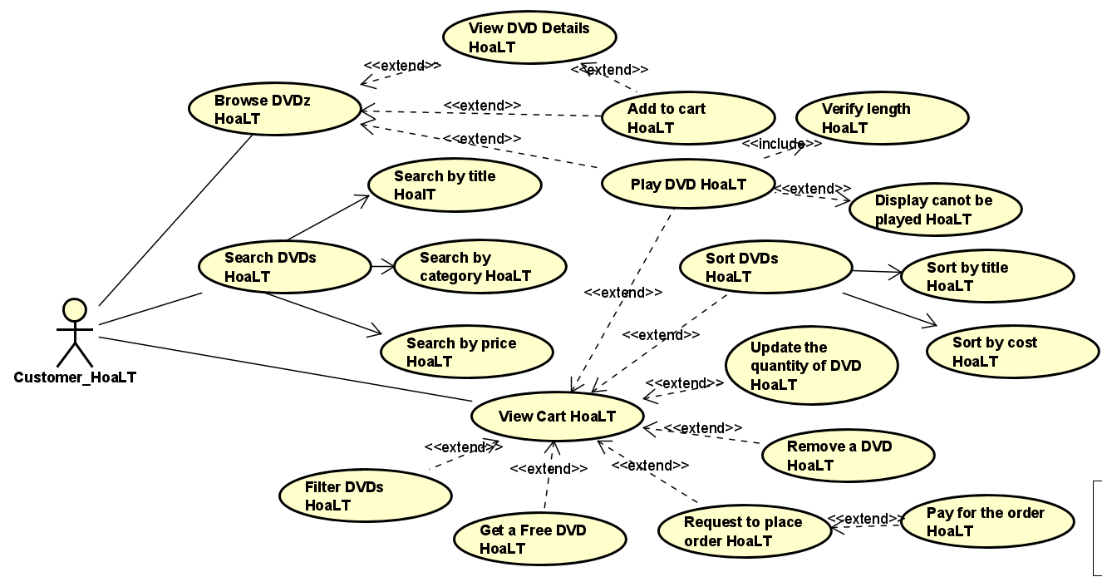

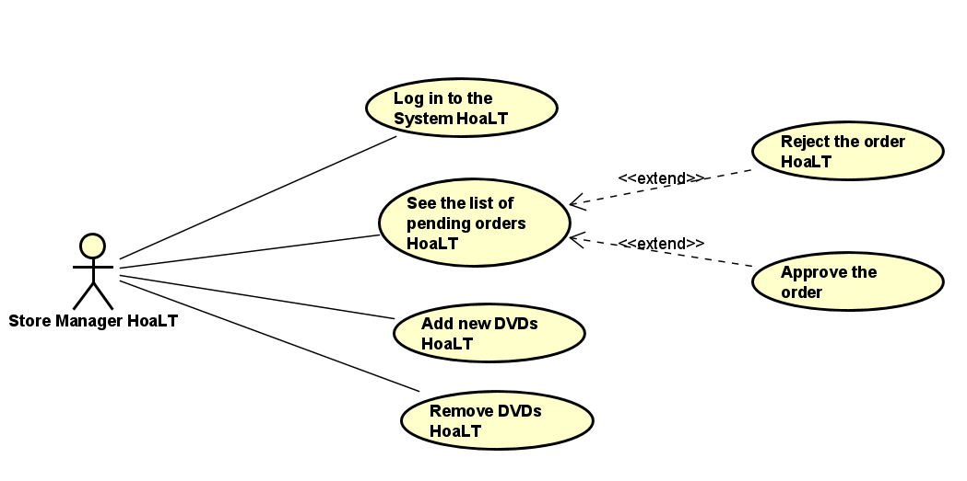

Figure 1: Use Case Diagram

Class Diagram

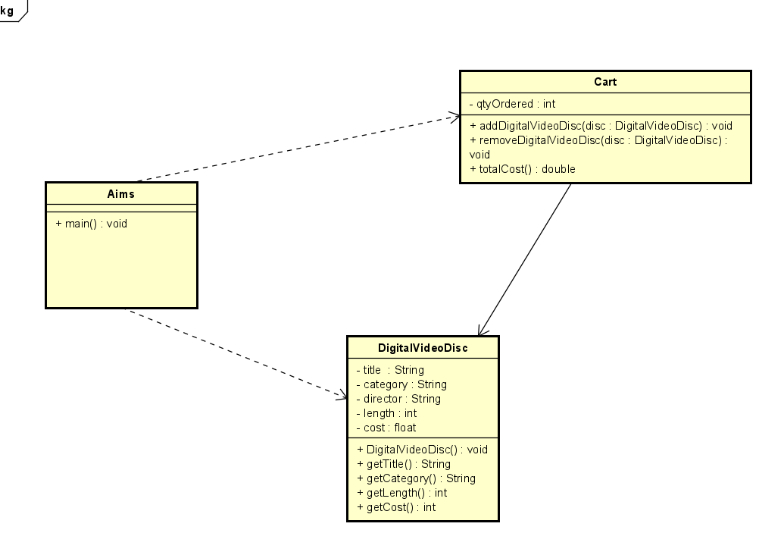Figure 2: Class Diagram

Source Code

Aims Class
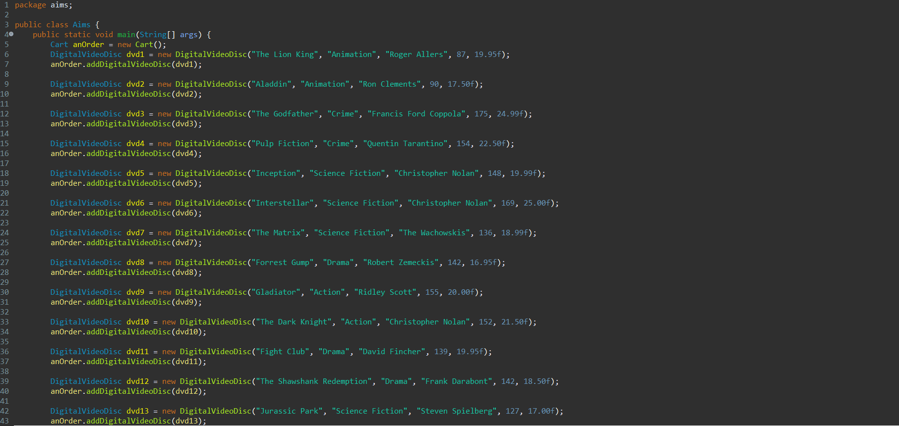
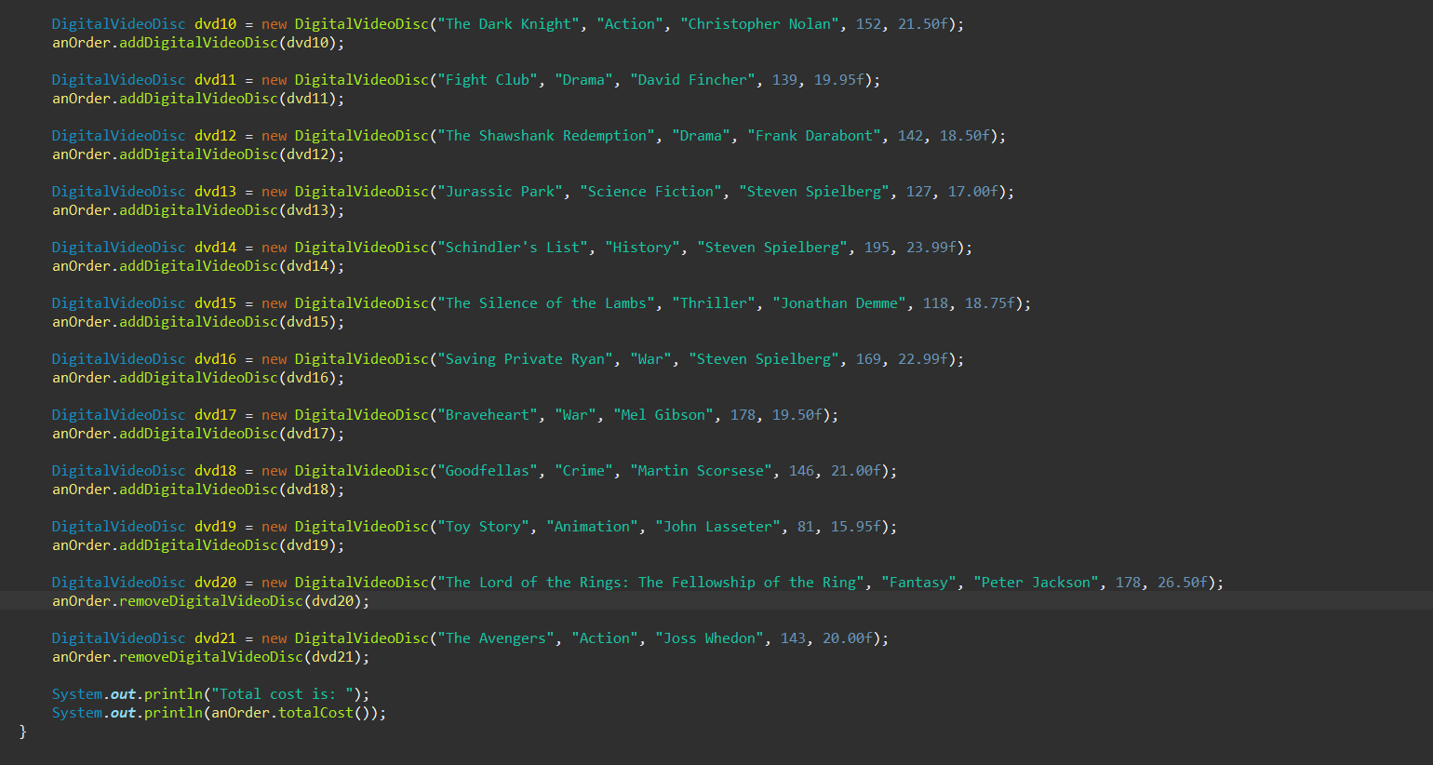Figure 3: Aims Class

DigitalVideoDisc Class
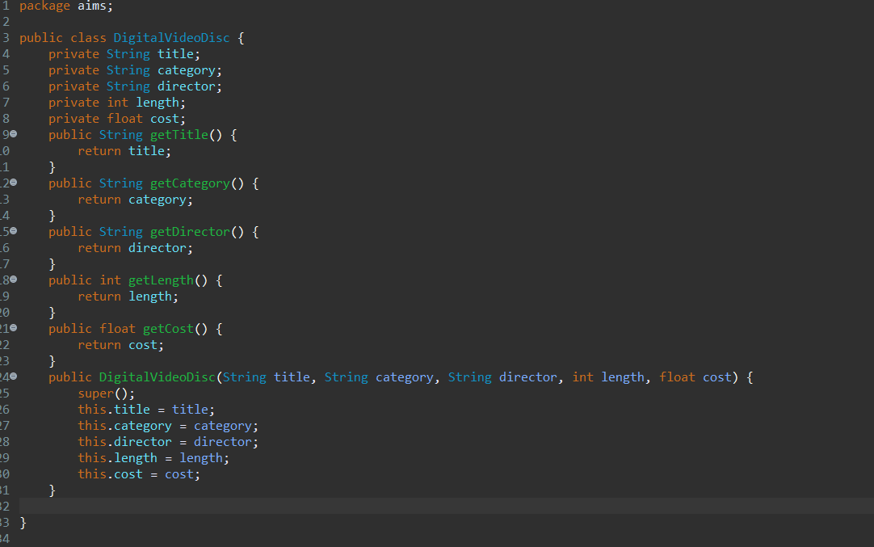Figure 4: DigitalVideoDisc Class 1

Cart Class
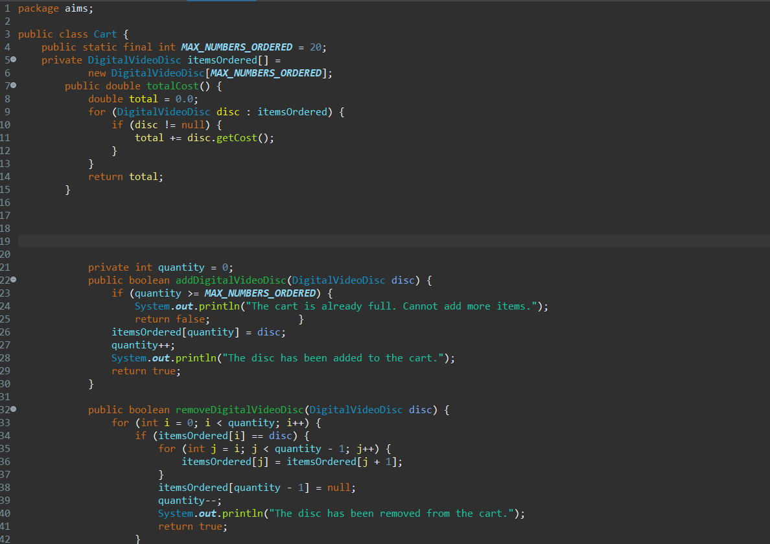
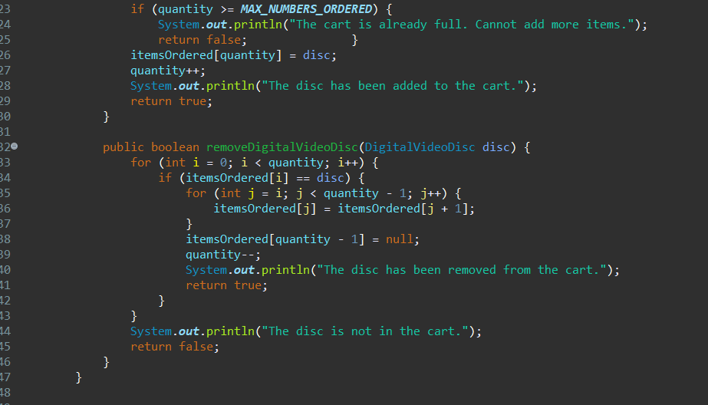Figure 6: Cart Class 1

Kết quả demo

Kết quả:

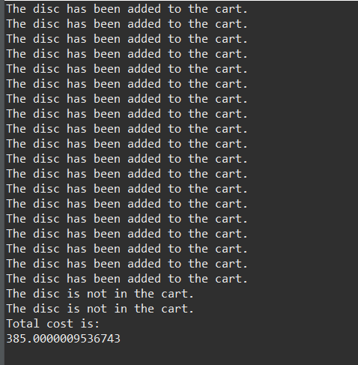
Figure 9: Result

